# IBEHS Writing Guidelines – Formatting of Reports

# Overview

The purpose of this guide is to ensure that iBioMed reports are presented in a clear and readable format. These guidelines are not comprehensive nor exhaustive and following these suggestions does not *guarantee* good marks on your written assignments. However, following this guide will help improve your report writing, data organization, and logical structuring of ideas. In the end, you must make the judgment of how to communicate your ﬁndings most effectively to your reader.

Remember that both the content and the style of the report are important. It is generally considered good practice to first write a broad outline of your report, which will help you structure your report as you write. This is followed by a first draft, which should be read over and revised two to three times until the final document is drafted.

# General Formatting and Style

Unless otherwise stated by your instructor, reports in the iBioMed program should have the following general formatting:

* Single-spaced
* Times New Roman 11-pt font
* 1-inch margins on letter-sized page
* All pages numbered (except for the title page) in the bottom right or bottom center

Avoid using any personal pronouns, such as I, we, and us. The report should be written in the present tense if it continues to be true, such as currently accepted scientific theories, and past tense when explaining work that has been done. For example, force **is** proportional to mass. Different masses **were** dropped on the subject’s toe and the resultant force **was** measured.

The file name for reports should follow the format indicated by the course instructor. Following the correct format for submissions makes the TA/instructor’s organization much easier.

# Cover Page

The page numbering of the report starts on the title page, although the page number is not shown on the title page. The title page must include:

* The title of the report
* All group member’s names, MACIDs, and student numbers
* The course code (e.g., IBEHS 1P10)
* The date submitted
* The name of the instructor

# Referencing

References are used to provide context and theories, comparisons, support to an argument, and an interpretation of information. A well-referenced report body is crucial for all reports. To prevent under referencing, ask yourself: “is every statement I make directly supported by the results?” If the answer is no, then reference your claim. To prevent over referencing, ask yourself: “if I take away this reference, is this claim still valid?” If yes, then get rid of the reference in the text body and bibliography. You do not need to reference common or widely accepted statements. For example, you do not need to provide a reference when discussing the basics of the Central Dogma.

All references at the end of the report must be cited in the report. The referencing style should be consistent throughout the report. Your instructor will inform you what referencing style should be used for your report. All referencing should be done using a reference manager such as Mendeley, Zotero or Endnote. This is because, while it is possible to manually add references, it is extremely time-consuming and prone to error.

# Figures and Tables

Figures and tables should always be mentioned and discussed in the text. The figures/tables should be inserted in the report as close to where it is initially mentioned, ideally on the same page but never on an earlier page than the textual reference. For very wide figures/tables that do not fit in the page in the portrait orientation, the figure/table and associated caption can be rotated 90 degrees on the page or by making that page landscape format.

## Captions

Figure and table captions should follow the following guidelines:

* Include the figure/table number. Figure/table should be numbered sequentially, in the order it appears in the report.
* Figure captions go below the figure. Table captions go above the table.
* Captions must be descriptive, cover the system being studied, the independent and dependent variables, and any other important conditions. If symbols are used in the figure, the caption should also address what the symbols represent if multiple data series are used, *and* no legend is present.

## Figures

Figures include graphs, drawings, and non-tabular material presented in the report. Any drawings or diagrams should be done using computer graphics, such as BIOVIA Draw for chemical structures, BioRender for biological constructs, and Inkscape for vector graphics. If the image is taken from another source, it must be referenced accordingly with appropriate rights and permissions statement such as “Reproduced/Adapted from [reference] with permission. Copyright ([year]) [publisher]”. ‘Reproduced from’ is when the image was copied and ‘Adapted from’ is when the source’s image is modified. All diagrams and schematics should be clearly labeled.

When formatting a figure, the font should look the same as the font used within the report. When creating a figure using MS Excel, never use the base format. Figures should not have a title, coloured backgrounds or outer frames when copied into the document. Legends can be used when necessary and placed within the blank space of the graph if it does not block any graphed data. If the legend obscures the information presented in the graph, they should be moved to the caption. Equations, including model fits to data, should always be placed in the caption. To ensure that the graph you are creating is effective to communicate the results, there must be a difference between the data series. Different marker styles and colours can be used to distinguish the data series but avoid relying solely on colour to distinguish data series, since printing is still often done in black and white. Use marker styles to primarily differentiate the data series.

As a rule of thumb, if a graph has more than 6 data series, you need to consider splitting them into multiple figures to prevent the figure from being overly crowded. The data collected will be plotted as symbols/points. Lines are typically used for regression analysis results or prediction from physical models.

On the graphs, error bars should be used whenever possible. Use standard error for the error bars whenever independent repeats are available. Do not use the error bar function in Excel, the standard error must be individually calculated and then applied for each data point. The x-axis is the independent variable and the y-axis is the dependent variable. The axis labels should include units.

Below is an example of a well-formatted graph included for reference.

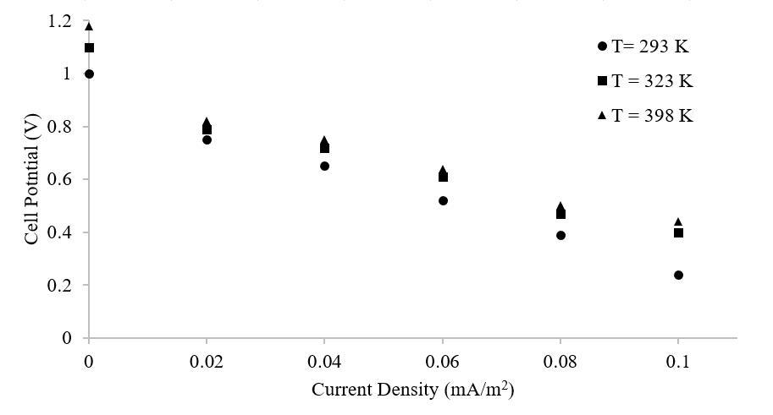

*Figure 1. The decay of fuel cell potential with increasing current density at 293 K , 398 K and 398 K.*

## Tables

Tables are another way to present results and raw data. Tables must have consistent units and significant digits. The table caption is placed above the table. Any explanatory details concerning the column headings, specific data points, or any units used can be put in a footnote below the table. The header row (top row) of the table should explain what each column will show and any associated units. Tables should not go outside the normal margins of the report and avoid having excessive dividing lines. Within the table, numbers should be right-justified, and all non-numerical entries are centered.

Below is an example of a well-formatted table for reference.

*Table 1. Effects of current density and temperature on fuel cell potential.*

|  |  |  |  |
| --- | --- | --- | --- |
| Current Density | Cell Potential (V) | | |
| (mA/m2) | T = 293 K | T = 323 K | T = 398 K |
| 0 | 1.00 | 1.10 | 1.18 |
| $$0.020$$ | 0.750 | 0.790 | 0.820 |
| $0.04$ 0 | 0.650 | 0.720 | 0.750 |
| $$0.060$$ | 0.520 | 0.610 | 0.640 |
| $0.08$ 0 | 0.390 | 0.470 | 0.500 |
| $$0.100$$ | 0.240 | 0.400 | 0.440 |

# Equations

When including a mathematical or chemical equation, they are part of the sentence displayed on a separate line. The equation must be centered with the equation number given in brackets, and the variables are italicized. After the equation, any new variables must be defined and with their units specified as appropriate. If more than 5 equations are in the report, create a ‘List of Symbols’ after the Table of Contents. In that case, you do not need to define the variables after the equation. When inserting an equation, use an equation editor, in MS Word: Insert à Symbols à Equations and in Google Docs: Insert à Equation.

For example:

The Beer-Lambert Law**,**used in spectroscopy, states that the concentration of a sample is directly proportional to the absorbance of a solution. The Beer-Lambert Law can be expressed as:

$A = εbc$ (1)

where *A* is absorbance (no units), *ε* is the molar absorptivity with units of L mol-1 cm-1 , *b* is the path length of the sample, usually expressed in cm, and *c* is the concentration of the compound in solution, expressed in mol L-1.

# Presenting Data and Numbers

## Rules for Writing SI Symbols

* The symbol should be written in lower case letters except for the first letter abbreviations if it is named after a person (e.g. K for kelvin or Pa for pascals) and for prefixes larger than “kilo” (e.g. M, G, T, etc.). The symbol for litre (L) is also capitalized. all other symbols are written in lower case.
* There should be a space between the numerical values and the first letter of the symbol   
  (e.g., 303.23 K)
* Symbols can be used with numbers, but units should be spelled out otherwise. For example, “There is 1 L of water” and “There are few litres of water”.
* Where different usages of an SI unit are used, the precise meaning can be specified in text or parentheses (e.g. 15 kPa (gauge)).

## Rules for Writing Numbers

* Decimals should be points, not commas.
* Long numbers are written in groups of three separated by a space, not a comma, before the decimal point (e.g 1 324 130.123).
* Use a cross (×), not a dot (·) for multiplication. Also, do not use the letter “x” for multiplication.
* Avoid “computer shorthand” notations. For example, do not use “2.0E-4” or “m^2”. These should be represented as 2.0 × 104 and m2 respectively.

## Rules for Significant Digits

* All numbers should be presented with proper significant digits
* For addition and subtraction, the final answer must have the same number of decimal places as the number with the least number of decimal places
* For multiplication and division, the final answer must have the same number of significant digits as the number with the least number of significant digits

## SI Units and their Multiples

* Try to express numbers between 0.1 and 1000 when possible. You can change the units. For example use 31 ns instead of $3.1×{10}^{-8} s$.
* Avoid using the power of 10 attached to the units or variable symbols in tables and figures where possible. For example use 2 cm instead of $2×{10}^{-2}m$.
* Only one unit prefix should be used, preferably on the symbol in the numerator-except kg which is a base units. For example, V/mm should be kV/m, or kJ/g should be MJ/kg.

## Multiplication and Division of Units

* Product of two units should be marked by a dot ($∙$). For example, $m∙N=meter Newton$.
* Division should be marked marked by a slash (/) or a negative exponent (-1).
* A hyphen (-) can be used when using a value as an adjective. (e.g. 2-hr run or 25-mm film).

## Preferred Units

*Table 2. The preferred units for common variables.*

|  |  |  |  |
| --- | --- | --- | --- |
| Variable | Preferred Units | Variable | Preferred Units |
| Length | $$m, cm, mm, μm$$ | Diffusion coefficient, axial dispersion coefficient | $$m^{2}/s, {cm}^{2}/s$$ |
| Area | $$m^{2}, cm^{2}, mm^{2}$$ | Energy, Work | $$J, kJ, MJ$$ |
| Volume | $$m^{3},dm^{3} \left(=L\right), cm^{3}$$ | Quantity of heat, enthalpy | $$J, kJ, MJ$$ |
| Velocity | $$m/s$$ | Pressure, Stress | $$Pa, kPa, MPa$$ |
| Mass | $$kg, g,mg$$ | Viscosity  Dynamic  Kinematic | $$Pa∙s, mPa∙s$$ $$m^{2}/s, mm^{2}/s$$ |
| Density | $$kg/m^{3}$$ | Thermal conductivity | $$W/(m∙K)$$ |
| Force | $$N,kN,mN$$ | Heat capacity | $$J/K, kJ/K$$ |
| Power | $$W, kW$$ | Specific heat capacity, entropy | $$J/(kg∙K), kJ/(kg∙K)$$ |
| Temperature | $$K, ℃$$ | Heat transfer coefficient | $$W/(m^{2}∙K)$$ |
| Frequency | $$s^{-1}or Hz, kHz, MHz$$ | Angular velocity | $$rad/s$$ |
| Molarity | $$mol/kg, mmol/g$$ | Amount of substance | mol (not g-mole), kmol (not kg-mole), mmol |
| Molar mass | $$g/mol, kg/kmol$$ | Molar concentration | Mol/m3, kmol/m3, mol/L |